Write down notes and observations encountered as we work through the project. These could be useful for discussions and presentations.

# Our Dataset (Downsampled Data)

## Photos with Multiple Classes

Some photos in our dataset contain multiple animals, hence one photo has two different labels. There are 21 photos that are classified into two classes, all of the classes are ‘Domestic Horse’ and ‘Bos Species’.

This file contains information about these dual-class images:

<https://drive.google.com/file/d/1VTDit-IoPei87RwV22j_Awli_J2MPdNm/view?usp=drive_link>

### Sample Photos

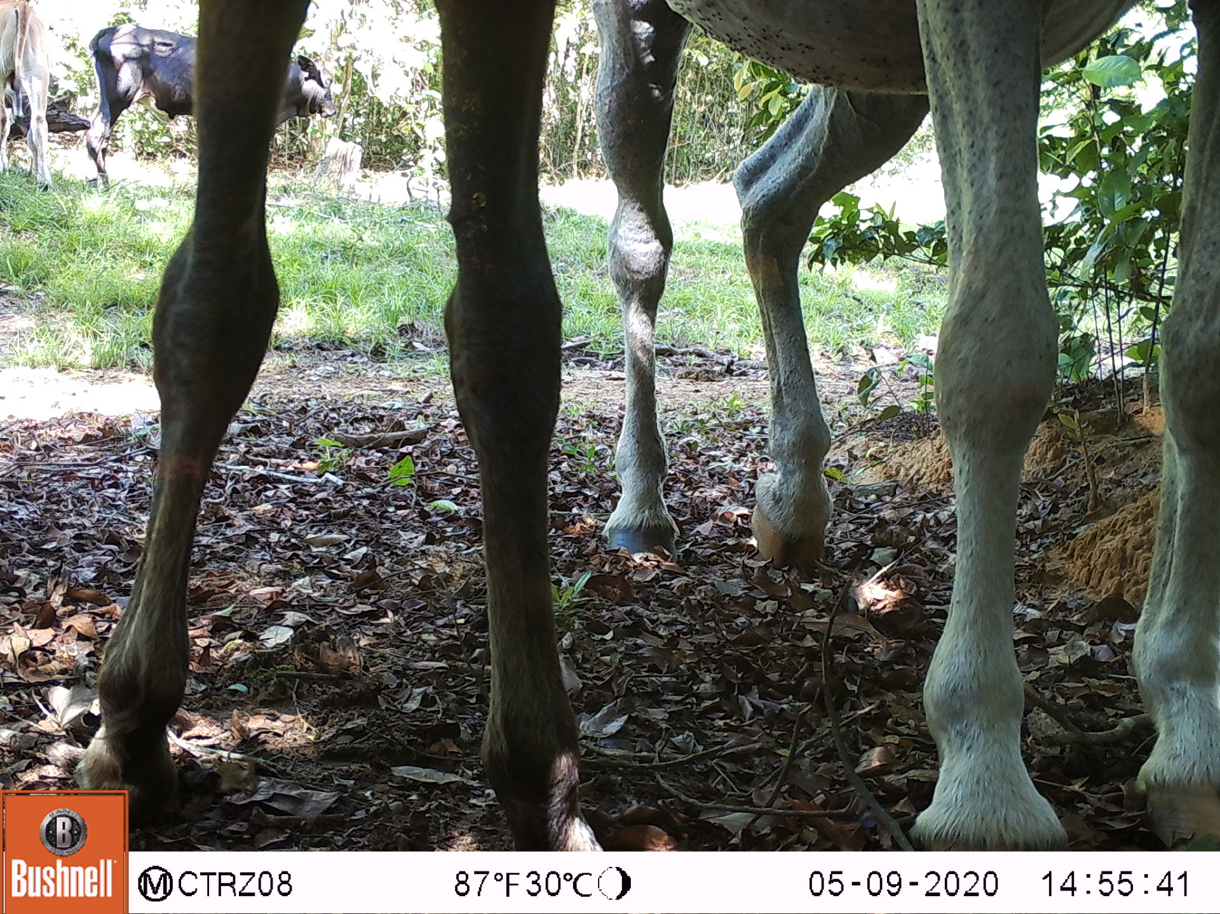 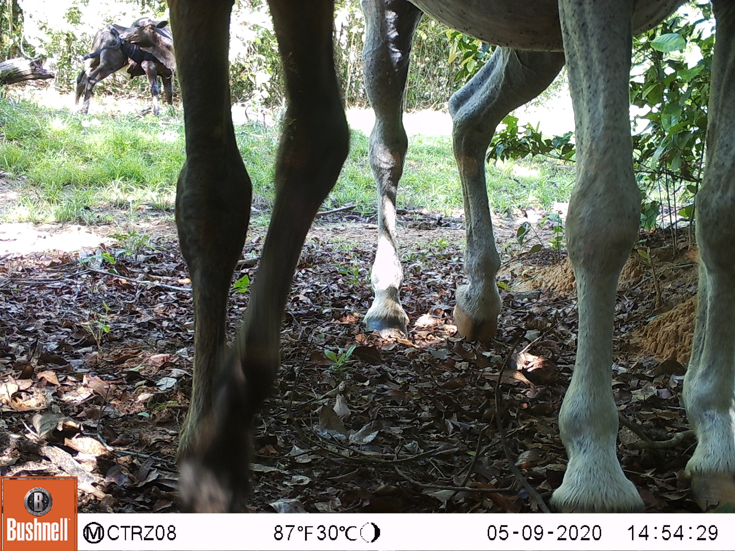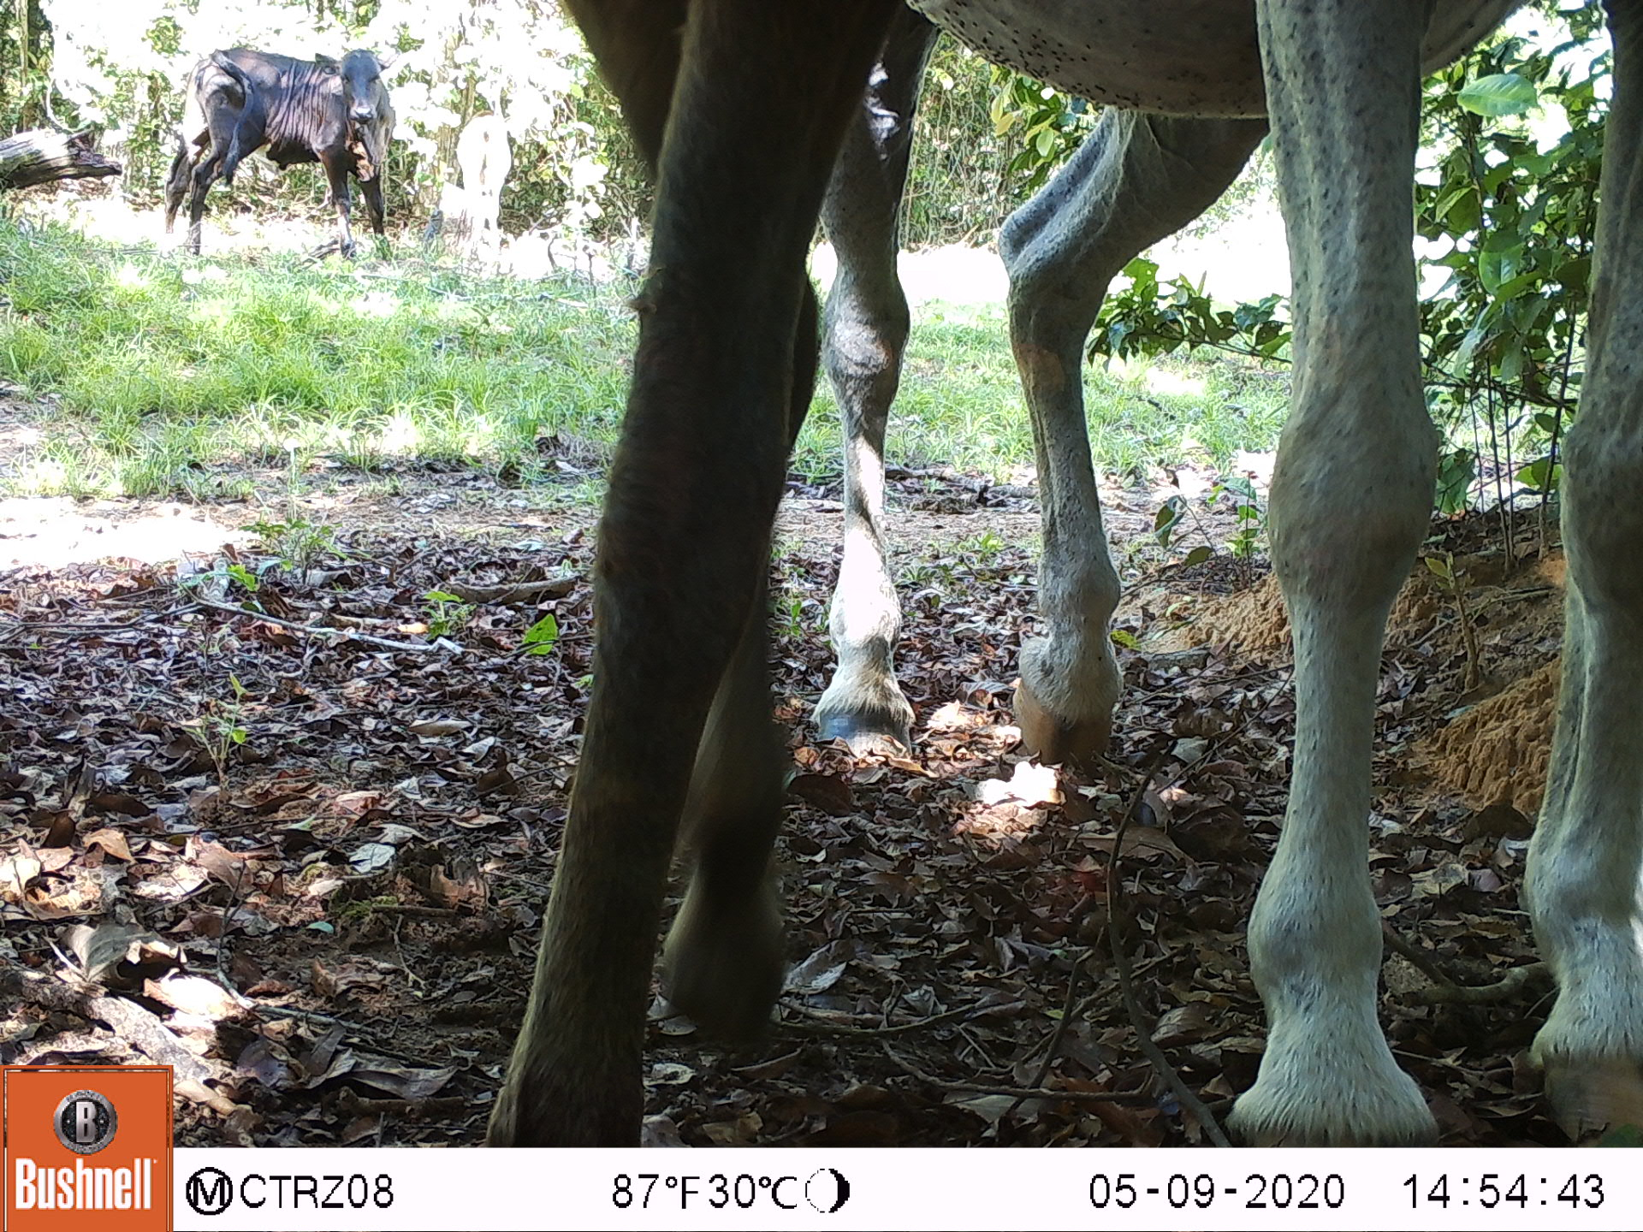

## Photos Missing from GCP Storage

Among the 21 dual-class photos, there are 2 images that are missing from the GCP storage hence not downloaded.

| **20648** | A07/06300682.JPG | 2020-06-30T06:48:43Z | 71da1d43-aed9-4879-8317-838023283d5f | Domestic Horse | 2 | A07 | 06300682.JPG |
| --- | --- | --- | --- | --- | --- | --- | --- |
| **20649** | A07/06300682.JPG | 2020-06-30T06:48:43Z | 71da1d43-aed9-4879-8317-838023283d5f | Bos Species | 2 | A07 | 06300682.JPG |
| **24333** | A07/06300683.JPG | 2020-06-30T06:48:44Z | d9e4cdbd-7eb0-4afc-b352-b3c3cdd5ee7a | Domestic Horse | 2 | A07 | 06300683.JPG |
| **24334** | A07/06300683.JPG | 2020-06-30T06:48:44Z | d9e4cdbd-7eb0-4afc-b352-b3c3cdd5ee7a | Bos Species | 2 | A07 | 06300683.JPG |